**CST-341 Design Report Template**

|  |  |  |
| --- | --- | --- |
| **Topic:** | *CLC 6* | |
| **Date:** | *11-17-19* | |
| **Revision:** | *6.0* | |
| **Team:** | 1. *Michael Sillanpaa* | |
| 1. *Brady Berner* | |
|  | |
|  | |
| **Weekly Team Status Summary:** | |  |  |  |  | | --- | --- | --- | --- | | **User Story** | **Team**  **Member** | **Hours**  **Worked** | **Hours Remaining** | | UML | Michael | *1* | *0* | | Sitemap | Michael | *1* | *0* | | JqueryUI | Brady | *1* | *0* | | Design Report | Brady | *1* | *0* | | Bug Fixes | Michael & Brady | *1* | *0* | |  |  |  |  | |  |  |  |  | |  |  |  |  | |  |  |  |  | |  |  |  |  | |  |  |  |  | |  |  |  |  | |  |  |  |  | | |
| **GIT URL:** | *https://github.com/BradyBerner/SpringCLC* | |
| **Peer Review:** | *Y* | We acknowledge that our team has reviewed this report and we agree to the approach we are all taking. |

**Planning Documentation**

**Work Breakdown:**

*We have decided that when breaking down work for this assignment we will meet in person, identify what tasks need to be down for this section(milestone) of the project, and then divide the work as evenly as we can, and each take approximately half the workload. In the event that one of us is unable to finish our entire workload within reasonable circumstances the other will pick up the slack for that milestone with the expectation that the workload balance will be evened out during the next milestone.*

**Design Documentation**

**Install Instructions:**

*Not yet applicable.*

**General Technical Approach:**

*We decided to do a media management platform as we thought it would be an interesting challenge to create a service that allows for users to upload and delete files. We also thought that it would be a good opportunity to learn about incorporating things like media players into an application. The fact that we did not have to host this application meant that we did not have to worry about the host providing us with limited disk space. So we thought it a good opportunity to do a project involving media that will likely be more storage intensive than past applications.*

**Key Technical Design Decisions:**

*We have decided to implement Bootstrap from the start since we feel that maintaining a constant design standard/pattern for our web pages will result in a better end product than trying to change all the designs to implement bootstrap when we get to it in class. As of right now we are also seriously considering implementing third party open source media players into our application for playback of video and audio files as we thought it a good opportunity to practice going through other’s documentation and implementing other software with our own. Lastly, we have chosen to use MySQL as our database solution for this project due to our familiarity with it and the tools we already have to work proficiently with it. We’ve also chosen to implement a service called FontAwesome as a way of putting icons on some of our pages. Jquery UI’s dialog boxes were implemented as a method of displaying messages and displaying errors.*

**Known Issues:**

*Not yet applicable*

**Risks:**

|  |  |  |  |
| --- | --- | --- | --- |
| Risk | Details | Strategy for Avoidance | Strategy for Mitigation |
| *Data loss* | *As with any work done on a computer there is an obvious risk of data loss due to any number of circumstances.* | *Keeping our tooling both software and hardware in good working order.* | *Saving work regularly, regularly pushing changes to GitHub, making sure that both parties have a copy of all work applicable to the project, and making regular backups.* |
| *Personal Emergency* | *An event where one of us has a personal emergency of some kind and is either unable to do their part of the work or only able to do a part of their work.* | *Speaking to the professor and making sure they are informed of any such situation, and if necessary/long term asking for the professor to split the group so each party may work on what time they have available.* | *Keeping each other informed of workload or any situations where one might not be able to finish everything on time or do as much work. Potentially each party picking up a little more of the workload than the other changing weekly* |
| *Storage Limits* | *Since we are doing a project that has to do with media files there is a possibility of not having enough storage for the files.* | *Making sure that the project is hosted on a computer with well-managed disk space and available room.* | *Using external storage solutions such as a USB or external hard drive.* |

**ER Diagram:**

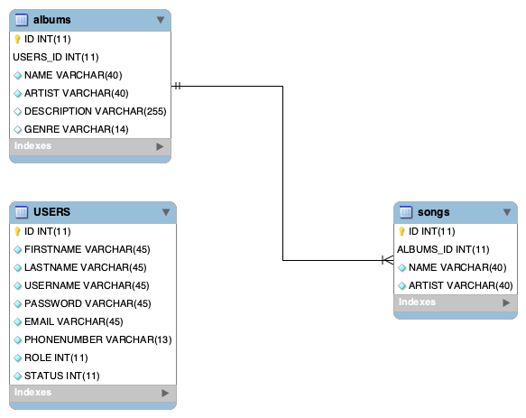

**DDL Scripts:**

*https://github.com/BradyBerner/SpringCLC/blob/master/Documentation/DDL%20Script.sql*

**Sitemap Diagram:**

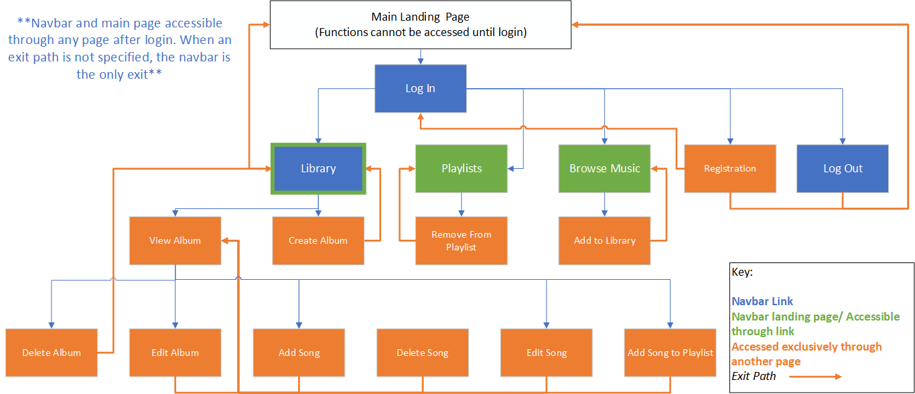

**User Interface Diagrams:**

Login: 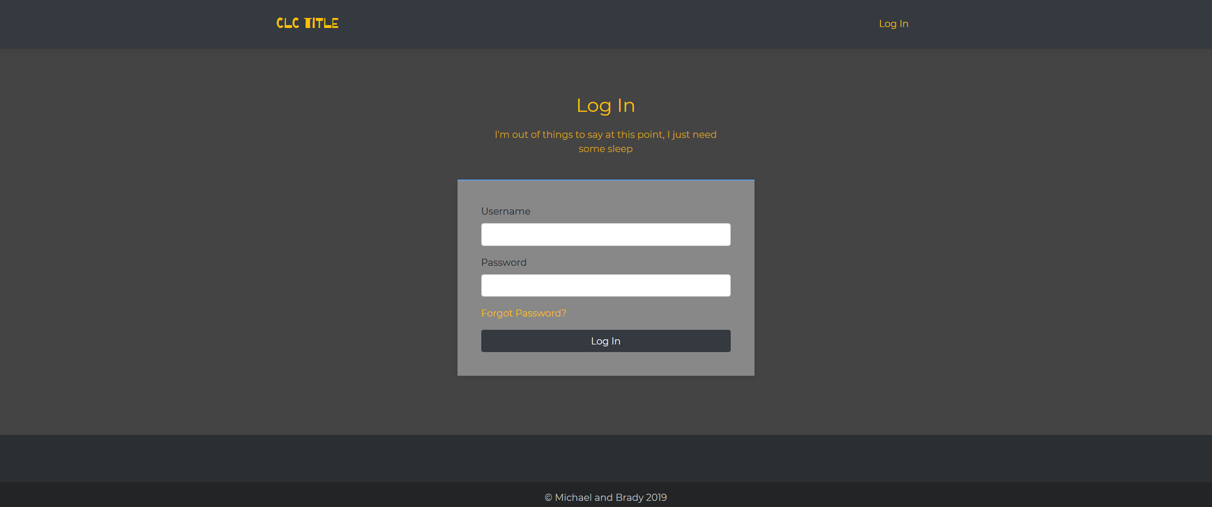

Registration:

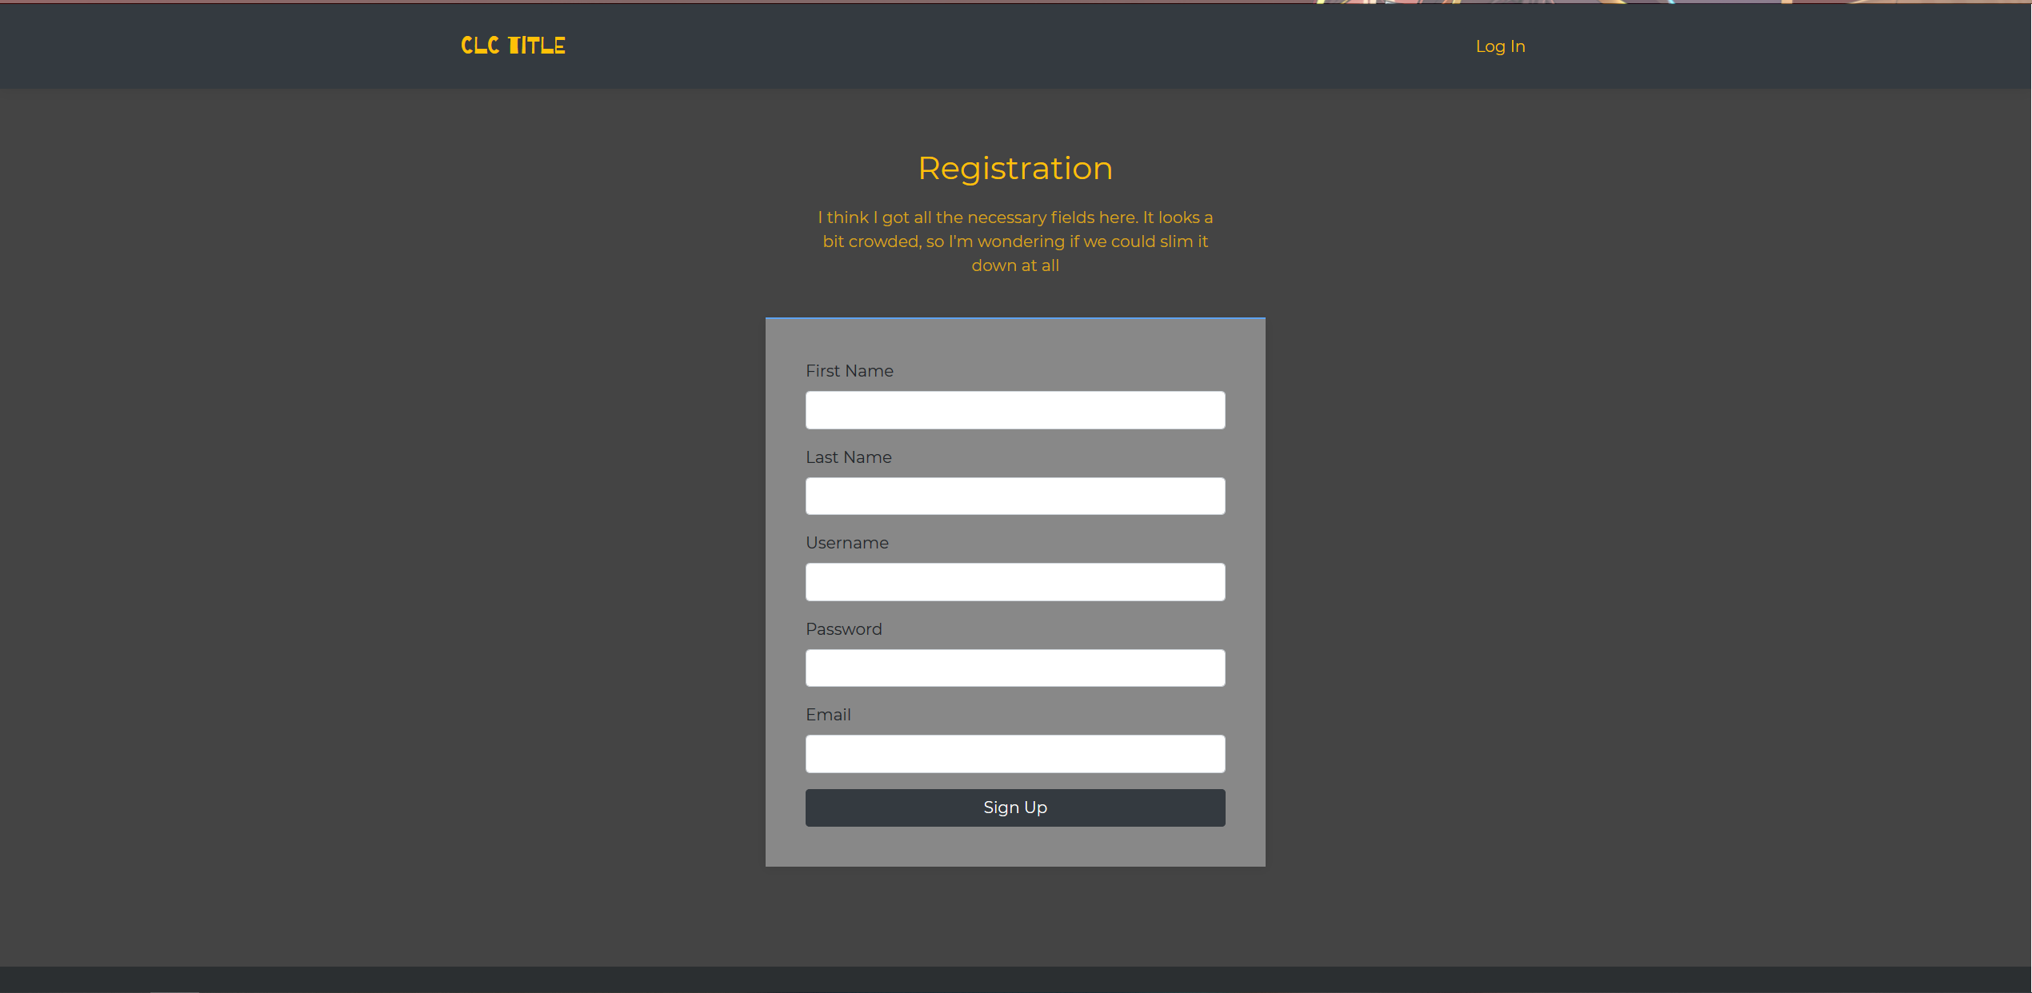

Library:

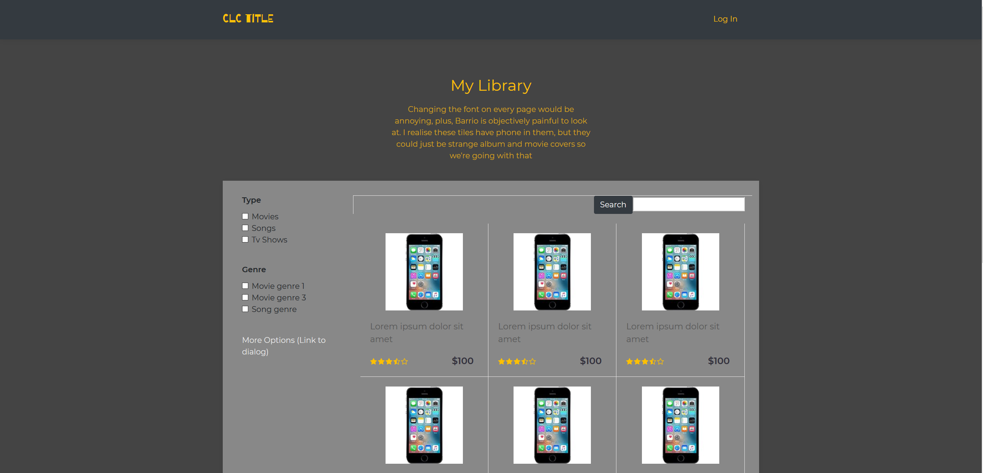

Landing Page:

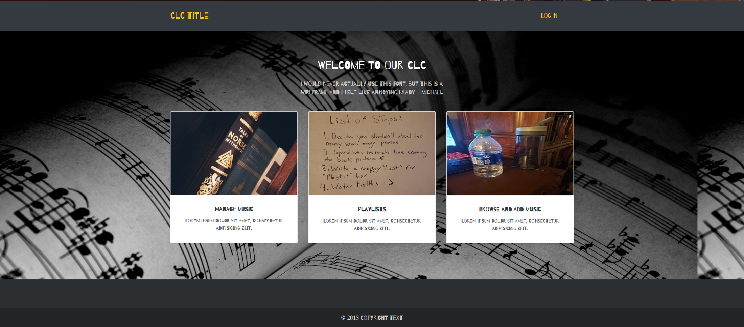

Landing Page 2:

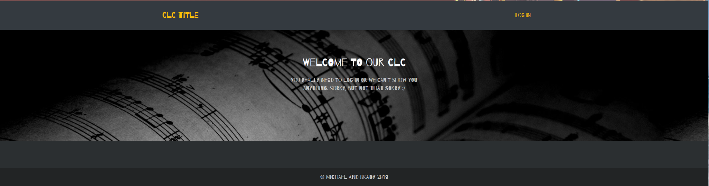

Album View:

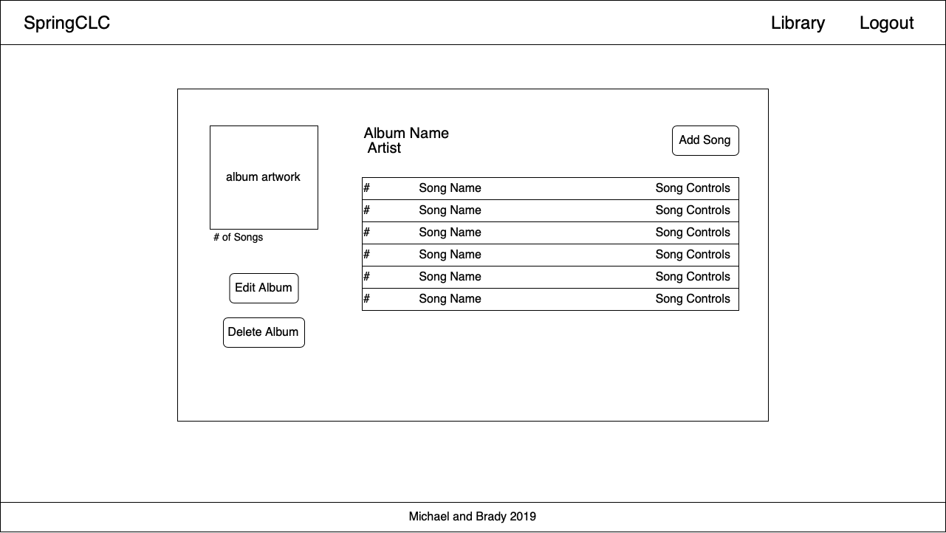

**Class Diagrams:**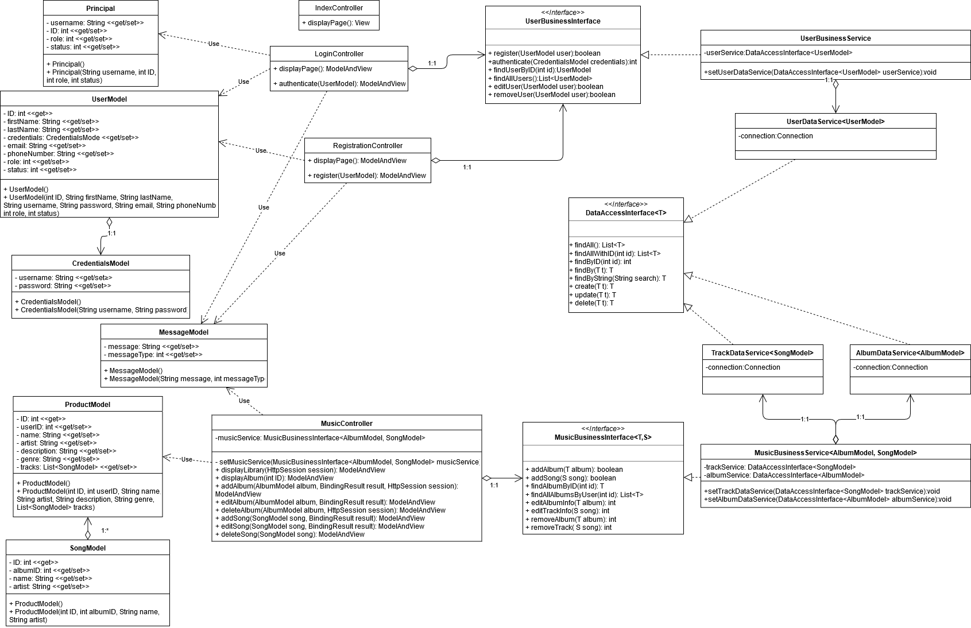

**Service API Design:**

*Not yet applicable*

**Security Design:**

*We have implemented basic validation rules to all form input.*

**Other Documentation:**

*Screencast Link: https://www.loom.com/share/a592f782d0934e91ad210c8b3196b136*